Health Visitor Programme - Weekly News

Issue 32
30th May 2013
……………………………………………………………………………………………………………

Information – Spreading the Word More Widely – Sharing Practice

Below are the reflections from current Health Visitor students and a newly qualified Health Visitors. It is really exciting to be able to share these experiences as it shows how well both students and newly qualified staff are being supported. We are aware that the numbers are large and that existing staff have risen to the challenge and are pro-actively supporting and developing this new work force.

Reflections captured

Student Reflection

"I was fortunate to be placed in a fabulous team and all of the staff were very welcoming and made my experience there very memorable. I received excellent support from my mentor and also from all the other team members. I felt much supported from the beginning and this has continued throughout my time with the team. My practice teacher was very knowledgeable and was always at the end of the phone if ever I needed her. She made contact regularly and made me feel empowered to complete my role with her praise and reassurance when I needed it."

"I have had a fantastic supportive placement and have been encouraged to do as much as possible with the skill mix team to better equip me for my career ahead. I have been supported through the consolidation phase as an autonomous practitioner knowing that support is at the end of the phone at all times, I have had time and encouragement from my PT to talk through anything at anytime which is invaluable. I am now regularly told how invaluable I have become and that makes me feel very rewarded for the hard work I put in on a daily basis.
I am well prepared for my career ahead and have been motivated to strive high by the role modelling from a few inspirational team members in my placement."

"Looking back on this year I realise how much I have learnt and how I have really developed in my new role. The first semester concentrating on Public health, local issues and learning the fundamental skills needed to effectively complete the health needs assessment. I was amazed how much information my mentor got from families in this first visit from what seemed to be a friendly chat. Questions were tactfully asked, relationships developed and expectations explored. When I started to try it felt more like a barrage of questions rather than a conversation. Now I leave visits and reflect on how my skill in this area has developed and how I have managed to discuss everything from brain development”

Newly qualified health visitor reflection

“I am one of those rare breeds called the newly qualified health visitor!”
“Training under the new ‘call for action’ Health Visitor Implementation Plan, we have gone through the challenge of portfolios, assignments, reflections and exams. The HV implementation plan has grand ideas of encouraging into practice 4200 extra nurses from all walks of life, previous clinical experience and expertise”
“We have now been let out into practice under supervision from our preceptorship mentors and regular group supervision. We have regular safeguarding supervision and, within the preceptorship sessions we discuss our caseloads, our experiences in practice and the development of the Building Community Capacity (BCC) project our proposal and due dates. We are reminded to take a half day a week for our BCC project to carry out profiling of our working area and to ascertain a local need within our community. During our clinical practice we are working within skill mixed teams, developing leadership skills, managing caseloads and maintaining high standards of care adhering to Suffolk County Council’s policies and guidelines. I can’t even begin to discuss System One!”
“I am thoroughly enjoying this new and challenging role! It’s all about being a lead professional in families care and giving on-the-spot evidence-based advice to families who have real needs and vulnerabilities within their everyday lives. It is about having excellent communication skills and managing your caseload within, what can sometimes be, challenging staffing situations. You are required to constantly think on your feet! It’s one of the professions with little thanks but plenty of rewards; it only takes one client to say you have made a real difference to their lives to make it worthwhile”
“The new Specialist Community Public Health Nurse has critiqued the psychologists, reviewed the social policies, and trawled through the child health literature to hopefully provide a gold standard of care to our clients. We have an idealistic notion of wanting to do the best for our families using our newly found knowledge to change the world….well, maybe one family at a time!”

……………………………………………………………………………………………………………

Information – Spreading the Word More Widely – Sharing Practice

Preceptorship Course

South West Essex undertake a robust preceptorship course with all newly qualified Health Visitors for a period of 6 months formal workshops and a further 6 months period of extended support. The extended period up to one year includes bi-monthly meetings which discusses caseload management and enables staff who are progressing through from newly qualified health visitor to competent health visitor a forum to reflect on issues relating to this transition. The programme has been recognised by the SUSTAIN review as an area of good practice and evaluated positively by the newly qualified health visitors themselves.

The preceptorship course is run by two community practice teachers who are known by the participants as they run some of the workshops for the SCHPNs in practice. They are therefore well qualified to be preceptors being experienced and competent health visitors who have received formal training to function in this capacity and who serve as a role model and a resource to newly qualified health visitors and school nurses (adapted from Alspach 2000).

Alspach (2000) offers 3 primary roles of preceptor - role model, socialiser, and educator.
The course is set up under two parts, the first being formal taught sessions the second provides a supervision process where the group is divided into two. This uses a restorative model in order to reduce the participants’ stress by enabling them to discuss concerns away from their workplace.

The benefits of this model have demonstrated that students feel supported within their transition are encouraged to reflect on practice and receive formal teaching on elements not covered within the initial training.

Caroline Ward

E: caroline.ward@nelft.nhs.uk
T: 01268 244674
.

Action – Invites will be received by Operational Leads soon to invite New Qualified Health Visitors

An official invite will be sent to the Operational Leads this week; please ensure to send the link provided out to your nominated New Qualified Health Visitors to register on to the event.

Further invites will be sent out to the remaining attendees next week with a link to the website to register for the event, the page is very simple and self-explanatory; example below

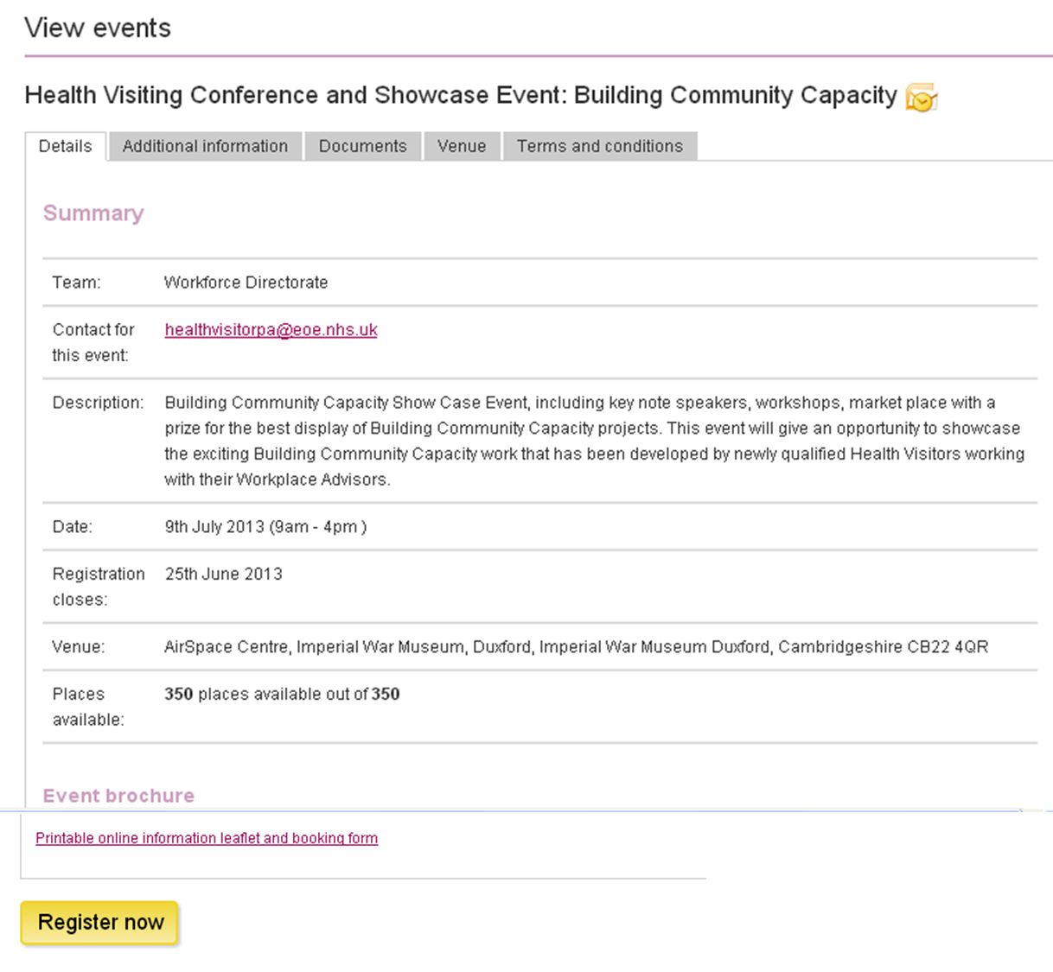

Reminder – Spreading the Word More Widely – Sharing Practice

Please ensure to get your article in to us in plenty of time.
The sharing practice article contents that we have received so far have been excellent, and will all be available on our website from next week. Details of the next 8 scheduled articles listed below:-

6th June – SW Essex
13th June – NE Essex
20th June – SE Essex
27th June – Mid Essex
4th July – Herts
11th July – Bedford
18th July – Luton
25th July – Cambs

Articles of up to 200 words in Word format highlighting an innovation or area of good practice (including contact details) are to be sent to Lucy Hall, HealthVisitorPA@eoe.nhs.uk by the Wednesday
…………………………………………………………………………………………………………….

Reminder – Follow us on Twitter East of Eng HV prog@HealthVisitors

We are now up to 49 followers which is excellent. Keep on following for some more updates
……………………………………………………………………………………………………………

Contacts

Julia Whiting, Health Visiting Programme Lead
M: 07535 638236
T: 01223 597512
E: Julia.whiting2@nhs.net

Lucy Hall, Health Visiting Programme Support
T: 01223 596858
E: healthvisitorpa@eoe.nhs.uk

