Health Visitor Programme - Weekly News

Issue 27
25th April 2013

……………………………………………………………………………………………………………
Information – Check out our updated website

If anyone has any suggestions for further inclusions or improvements let Lucy know

www.eoedeanery.nhs.uk
……………………………………………………………………………………………………………

Information – Spreading the Word More Widely – Sharing Practice

Cambridgeshire Community Services Case Study

Developing and delivering a Health Visiting/Children’s centre partnership agreement

Overview: The main aims of the partnership agreement are as follows;

- to outline the vision and strategic agreement for delivery of an integrated Healthy Child Programme between Health Visiting and Children’s Centres in Cambridgeshire

- to describe the operational agreements that have been developed to support frontline practitioners to embed this service change into operational practice

Achievements:

- The change was scoped, developed and implemented in partnership with the local Children’s Centre

- A joint steering group for the development and delivery of the partnership was forged which enabled appropriate decision making to take place in a timely approach

- The change was successfully led by the Children’s Centre development coordinator and the Health Visiting Service Manager

- All 40 Children Centre Managers and 7 Health Visiting Managers were fully engaged and participated throughout the development and implementation of the partnership agreement

- Full commitment has been achieved from Health Visiting and Children’s Centres to the fundamentals of the Antenatal Care Pathway and the wider CAF processes which include monthly meetings( Early Years LARMS) between Health Visiting, Midwifery and Children’s Centres

- Full commitment by Children’s Centres and Health Visiting to integrated training programmes, delivered in Children’s Centres, which will improve understanding of roles and responsibility across services for children 0-5 and their families. This should result in earlier identification of need and timely access to specialist services

- Each Children’s Centre or cluster of Children’s Centres has a named Health Visitor to ensure the effective planning, implementation and evaluation of their integrated Healthy Child Programme at a local level.

All first time mothers and mothers identified as needing additional post natal support are invited to a series of 6 Post Natal Advice sessions. This has been provided as part of a rolling programme delivered by Health Visiting and Children’s Centre.

- 1 Year development check and 2.5 year development check where possible are delivered in the Children’s centres and delivered jointly where appropriate

- The partnership agreement outlines the full delivery of the new offer with a timeframe aligned to the Health Visiting service growth

For more information or a copy of the Partnership Agreement please contact Fleur Seekins, Professional Lead, CCS Fleur.seekins@nhs.net

E: Emma.Morley@ccs.nhs.uk
T: 01480 418689

…………………………………………………………………………………………………………….

Information – Recruitment to 13/14 Health Visitor Training places

Organisations are making excellent progress towards reaching our goal of recruiting 386 student Health Visitors in 13/14. A total of 175 places have been offered already which is very encouraging at this time of year.
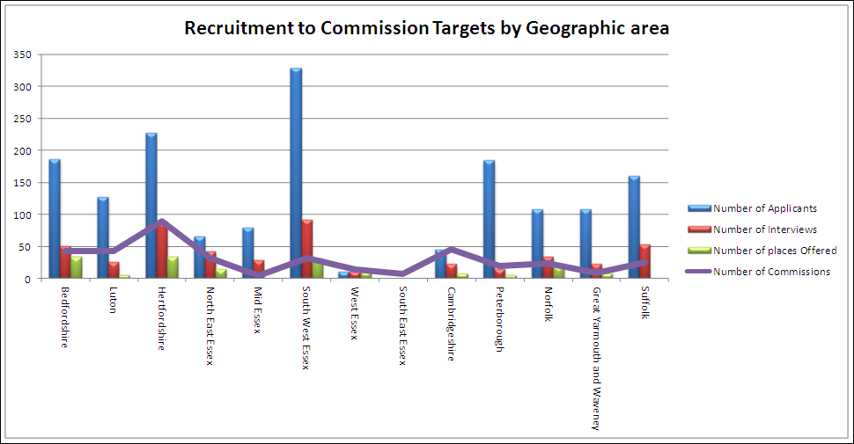

*Information compiled from data submitted by provider organisations*
…………………………………………………………………………………………………………….

Information – NHS Jobs – closing Tuesday next week

The following new posts are now being recruited to, to support Health Visitor Programme implementation in the East of England. If you would like to discuss please contact Julia Whiting on 07535 638236

Job title: Health Visitor Locality Lead - Cambridge and Peterborough 0.6 wte
Contract: Fixed term
Band: 8b
Salary: £45,707 to £56,504 per annum
Location: Cambridgeshire/Peterborough tbc
Closing Date: Midnight on 30th April 2013

If you would like to view this post, please visit www.jobs.nhs.uk and enter the reference number 984-HEE220-EOE in the quick search text box.

Job title: Health Visitor Locality Lead - Bedfordshire & Hertfordshire 0.8 wte
Contract: Fixed term
Band: 8b
Salary: £45,707 to £56,504 per annum
Location: Cambridgeshire/Peterborough tbc
Closing Date: Midnight on 30th April 2013

If you would like to view this post, please visit www.jobs.nhs.uk and enter the reference number 984-HEE216-EOE in the quick search text box.

Job title: Health Visitor Locality Lead Norfolk & Suffolk 0.4 wte
Contract: Fixed term
Band: 8b
Salary: £45,707 to £56,504 per annum
Location: Norfolk Suffolk tbc
Closing Date: Midnight on 30th April 2013

If you would like to view this post, please visit www.jobs.nhs.uk and enter the reference number 984-HEE217-EOE in the quick search text box.

Job title: Health Visitor Locality Lead – Essex 0.6 wte
Contract: Fixed term
Band: 8b
Salary: £45,707 to £56,504 per annum
Location: Essex
Closing Date: Midnight on 30th April 2013

If you would like to view this post, please visit www.jobs.nhs.uk and enter the reference number 984-HEE218-EOE in the quick search text box.

Job title: Health Visitor Programme Manager 0.6 wte
Contract: Fixed term
Band: 7
Salary: £30,764 to £40,558
Location: Negotiable across East of England
Closing Date: Midnight on 30th April 2013

If you would like to view this post, please visit www.jobs.nhs.uk and enter the reference number 984-HEE219-EOE in the quick search text box.

…………………………………………………………………………………………………………….

Information – please note conference 4th July – Getting it right from the beginning can now issue invoices

……………………………………………………………………………………………………………

Reminder – Follow us on Twitter East of Eng HV prog@HealthVisitors

So far we have 35 followers, looking to increase this number. We are also in the middle of updating our website further news to follow on this.

……………………………………………………………………………………………………………

Reminder – Spreading the Word More Widely – Sharing Practice

The sharing practice article contents that we have received so far have been excellent, and will all be available on our website from next week. Please could you ensure that you set up reminders for your next Communities of Practice article to ensure that your articles are sent in on time. Details of the next 6 scheduled articles listed below:-

2nd May - P’Boro
9th May - ECCH
16th May - Norfolk
23rd May - Suffolk
30th May - W Essex
6th June – SW Essex

Articles of up to 200 words highlighting an innovation or area of good practice (including contact details) are to be sent to Lucy Hall, HealthVisitorPA@eoe.nhs.uk by the Wednesday

…………………………………………………………………………………….

Contacts

Julia Whiting, Health Visiting Programme Lead
M: 07535 638236
T: 01223 597512
E: Julia.whiting@eoe.nhs.uk

Lucy Hall, Health Visiting Programme Support
T: 01223 596858
E: healthvisitorpa@eoe.nhs.uk

