Health Visitor Programme - Weekly News

Issue 29
9th May 2013
……………………………………………………………………………………………………………

Information – Spreading the Word More Widely – Sharing Practice

This week we are really pleased to incorporate reports from two recent Communities of Practice events. These are excellent reports and it’s very exciting to see the development of our Communities of Practice.

“Bringing Health Visitors in Hertfordshire, Bedfordshire and Luton together”

(Community of practice for Herts, beds and Luton, 1st May 2013.)

The group was attended by Health Visitors and Community Staff nurses from across the organisations. Cath Slater (Deputy General manager – Hertfordshire) reflected on the leaning from being an Early Implementer site and how it has focused the service on improving the uptake of the 2.5 year review and by using the Ages and Stages improving the quality of the review itself. Achieving an increase in uptake from 37% to 97% has been a huge achievement; the challenges were getting the System 1 recording templates correct and implementing the training across such a large geographical area.

Kay Gilmour (Transformation lead – Hertfordshire) introduced the change models used in the organisation to make sure that service improvements are robust and sustainable. Kay used a creative approach to help participants reflect how they feel about the healthy child programme and to share the enthusiasm and passion in the room.

Jackie Syme (Interim Practice development lead 0 – 19 , SEPT) shared the exciting work that has gone into Bedfordshire’s recent success in gaining Unicef Baby Friendly status, using a patient story to bring Baby Friendly to life and to illustrate the impact it has had.

Participants completed a case study during the session which will be shared across the organisations as another effective way of sharing good practice.

The event had a positive feel with lots of enthusiasm and passion - everyone is looking forward to the next event !!

E: Cath.Slater@hchs.nhs.uk
T: 01707 388 004

…………………………………………………………………………………………………………….

Communities of practice event 23.4.13
A focus on antenatal contact

A Reflection/ Case study on the morning itself

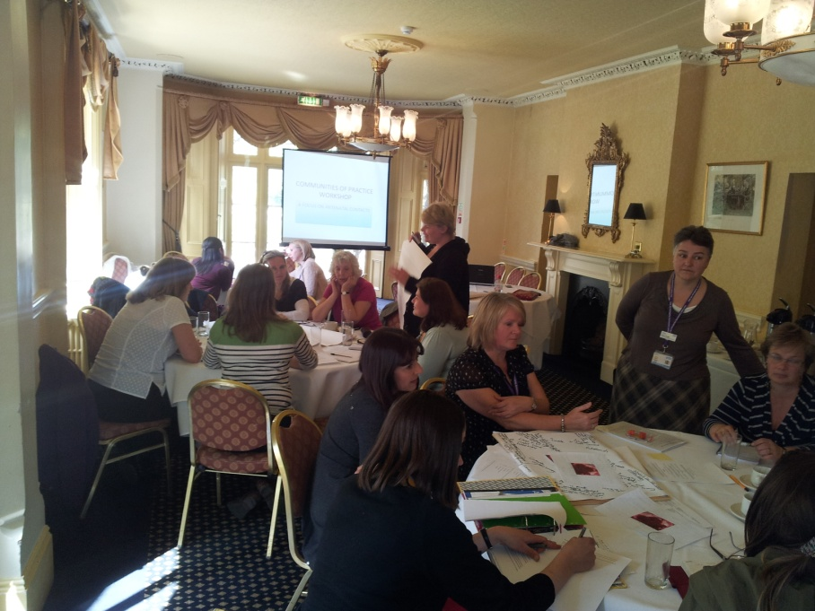

Today we held a community of practice workshop for the Norfolk, East Coast and Suffolk cluster. 23 people from across the three areas came together today for a communities of practice workshop which focused on antenatal contacts.

Today was a day to understand the concept of communities of practice, share knowledge and current models of good practice with colleagues, learning from each other. We were able to identify case studies of good practice which are cascaded out amongst the three organisations.

Guest speakers kicked off the morning by presenting a short example of practice in their area. Claire Jones (HV for East coast community health care) shared with us their pregnancy birth and beyond programme, Hayley Cross (HV for Suffolk county council) talked about their Healthy Child Collaborative and I was there to feedback our audit results showing what families across Norfolk thought of their routine universal antenatal contact.

The day generated much discussion and there was a plethora of good ideas and sharing of innovations, many people shared their ideas, resources and innovations and there was rich discussion around the ins/outs of each when working with families.

All presentations are attached for your information. Overall the day was welcomed by all and time was given to ponder what the topic of future workshops will be. Ideas are welcomed so if there is an area of practice that you would like to explore within our cluster then please let your managers know.

The next community of practice workshop is planned for September time (Dates to follow).

Mandy Wagg (Norfolk Community Health and Care NHS Trust)

…………………………………………………………………………………………………………….

Information & Action – SAVE THE DATE

We are delighted to give you more information regarding the BCC conference in the Summer. Please ensure to bring this to the attention of your students and newly qualified Health Visitors. Booking will be open within the next few weeks, in the meantime get this in your diary.

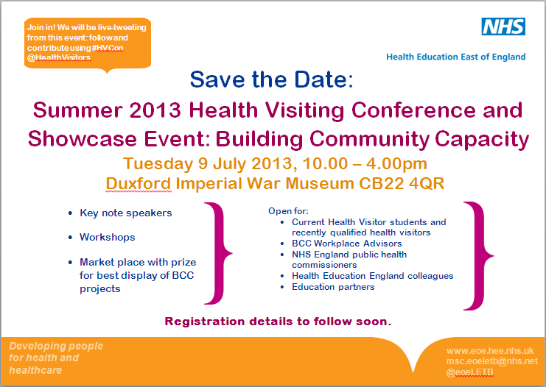

…………………………………………………………………………………………………………….

Great news – There is now an East of England venue University Campus Suffolk, Waterfront Building, Ipswich 3rd – 4th June

*Please ensure you sign up for this event, this is a great opportunity to ensure national organisations hold future events in the East of England*

Become an iHV
Perinatal Mental Health Champion
The Department of Health has commissioned the Institute to create up to 400 perinatal mental health champions. They will work with iHV-developed evidence based tools to train colleagues in the detection and management of perinatal depression, and act as a local expert resource for their colleagues, supported by the iHV. This free training, which provides 14 hours CPD, will be delivered around England from May to August, 2013.
If you are a specialist practice educator, an experienced health visitor or have a specialist interest in this field and are prepared to embrace the Champion’s role on behalf of your colleagues, consider joining us.
Oxford 23-24 May
Ipswich 3-4 June
Preston 12-13 June
Guildford 20-21 June
Warwick 27-28 June
Leeds 4-5 July
Bristol 10 July – 17 July, dates TBC
East Midlands 10 July – 17 July, dates TBC
London 22-23 July
Warrington 1-2 August
Go to http://www.ihv.org.uk/ for venues updates
Please register an interest for any of the venues at pnd@ihv.org.uk
Lead Trainer: Dr Jane Hanley, Health Visitor and President of the International Marcé Society

…………………………………………………………………………………………………………….

Reminder – Follow us on Twitter East of Eng HV prog@HealthVisitors

We are now upto 41 followers which is excellent. Keep on following for some more updates
……………………………………………………………………………………………………………

Reminder – Spreading the Word More Widely – Sharing Practice

The sharing practice article contents that we have received so far have been excellent, and will all be available on our website from next week. Please could you ensure that you set up reminders for your next Communities of Practice article to ensure that your articles are sent in on time. Details of the next 4 scheduled articles listed below:-

16th May - Norfolk
23rd May - Suffolk
30th May - W Essex
6th June – SW Essex

Articles of up to 200 words in Word format highlighting an innovation or area of good practice (including contact details) are to be sent to Lucy Hall, HealthVisitorPA@eoe.nhs.uk by the Wednesday

…………………………………………………………………………………….

Contacts

Julia Whiting, Health Visiting Programme Lead
M: 07535 638236
T: 01223 597512
E: Julia.whiting2@nhs.net

Lucy Hall, Health Visiting Programme Support
T: 01223 596858
E: healthvisitorpa@eoe.nhs.uk

